

**Payroll System**

**POSEgg004**

HUEVO – FEBRUARY 2017

|  |  |  |
| --- | --- | --- |
| **SCRUM TEAM** | **SPRINT NAME AND DURATION** | **CHANGES** |
| Huevo | SPRINT#4  04/Feb/17 12:19 AM  to  18/Feb/17 3:30 AM | * **Login page error message** |

**POSEgg004**

This story includes the creation of Login page error message. The Login page consists of login page error message. It will appear when user inputs invalid credentials. Invalid username and password.

The team are creating login page error message to validate the username and password to know if users 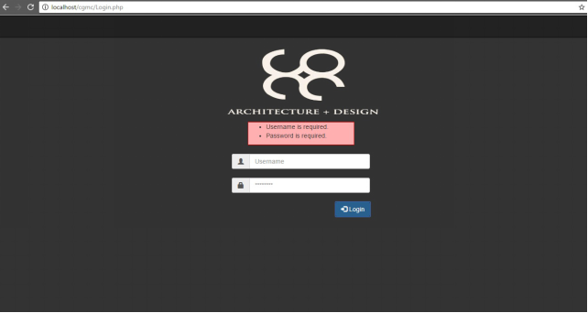credentials are valid or not and to provide security of the user.

1. Login Page Error Message

It will appear when user input invalid credentials (username and password) .